|  |  |  |  |  |  |  |
| --- | --- | --- | --- | --- | --- | --- |
|  |  |  |  |  |  |  |
|  |  |  |  |  |  |  |
|  |  |  |  |  |  |  |
|  |  |  |  |  |  |  |



[Sidebar Title]

[Sidebars are great for calling out important points from your text or adding additional info for quick reference, such as a schedule.

They are typically placed on the left, right, top or bottom of the page. But you can easily drag them to any position you prefer.

When you’re ready to add your content, just click here and start typing.]

[Video provides a powerful way to help you prove your point](https://video.com). When you click Online Video, you can paste in the embed code for the video you want to add. You can also type a keyword to search online for the video that best fits your document.

**Ok**

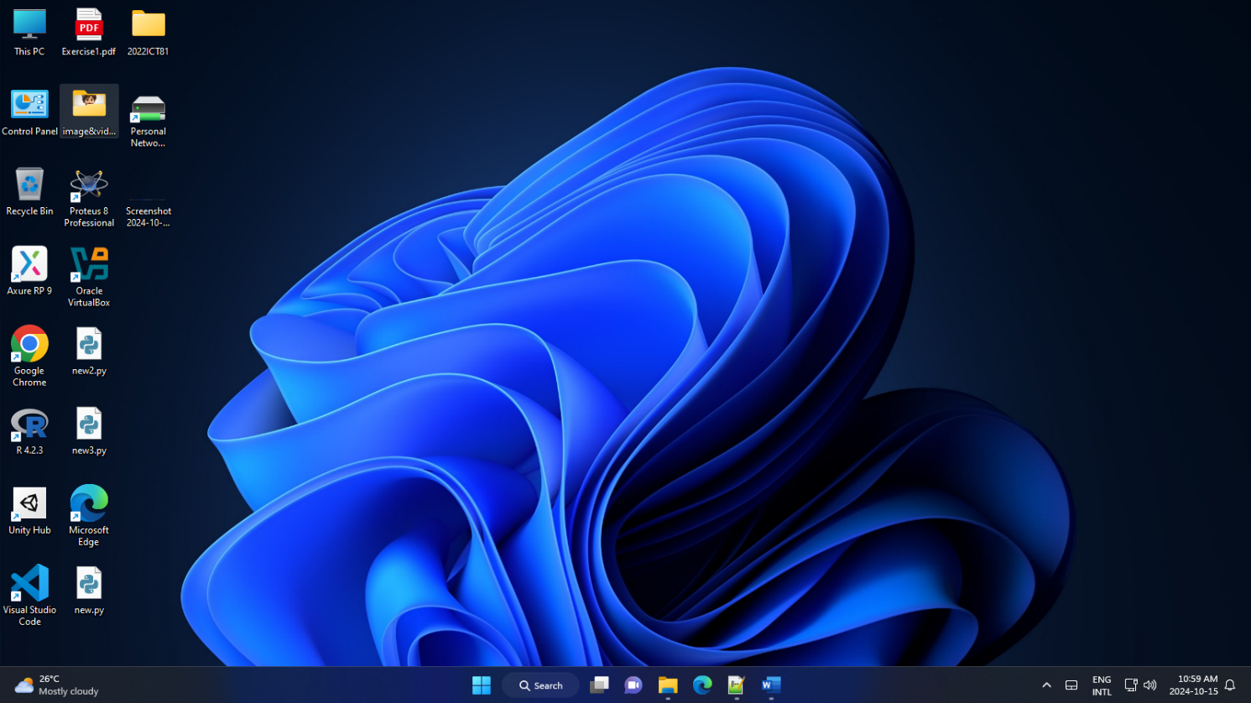

[Video provides a powerful way to help you prove your point](https://video.com). When you click Online Video, you can paste in the embed code for the video you want to add. You can also type a keyword to search online for the video that best fits your document.

To make your document look professionally produced, Word provides header, footer, cover page, and text box designs that complement each other. For example, you can add a matching cover page, header, and sidebar. Click Insert and then choose the elements you want from the different galleries.

T

o make your document look professionally produced, Word provides header, footer, cover page, and text box designs that complement each other. For example, you can add a matching cover page, header, and sidebar. Click Insert and then choose the elements you want from the different galleries.

Themes and styles also help keep your document coordinated. When you click Design and choose a new Theme, the pictures, charts, and SmartArt graphics change to match your new theme. When you apply styles, your headings change to match the new theme.